**DAILY ROUTINE**

**Day of the week**

**Morning**

**Noon**

**Afternoon**

**Evening**

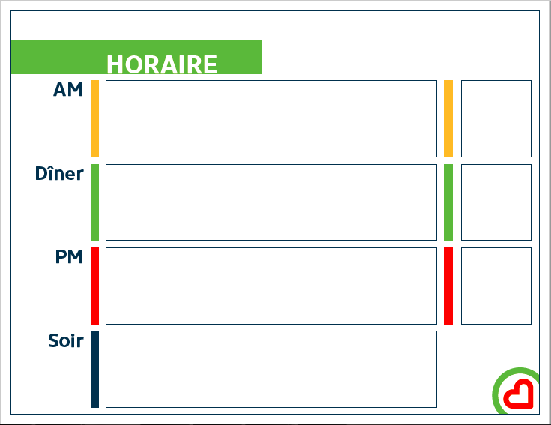

**DAILY ROUTINE**

**Day of the week**

**Morning**

**Noon**

**Afertnoon**

**Evening**

**with**

**with**

**with**



**⋅⋅ Weather ⋅⋅**

|  |  |  |  |  |  |  |  |  |
| --- | --- | --- | --- | --- | --- | --- | --- | --- |
| 7h00 | 7h30 | 8h00 | 8h30 | 9h00 | 9h30 | 10h00 | 11h00 | 11h30 |
|  |  |  |  |  |  |  |  |  |

|  |  |  |  |
| --- | --- | --- | --- |
| 12h00 | 12h30 | 13h00 | 13h30 |
|  |  |  |  |

|  |  |  |  |  |  |  |
| --- | --- | --- | --- | --- | --- | --- |
| 14h00 | 14h30 | 15h00 | 15h30 | 16h00 | 16h30 | 17h00 |
|  |  |  |  |  |  |  |

|  |  |  |  |  |  |  |  |
| --- | --- | --- | --- | --- | --- | --- | --- |
| 17h30 | 18h00 | 18h30 | 19h00 | 19h30 | 20h00 | 20h30 | 21h00 |
|  |  |  |  |  |  |  |  |

**CUT-OUT ICONS**

