**⋅⋅ Température ⋅⋅**

**HORAIRE**

**Jour de la semaine**

**AM**

**Dîner**

**PM**

**Soir**

**avec**

**avec**

**avec**

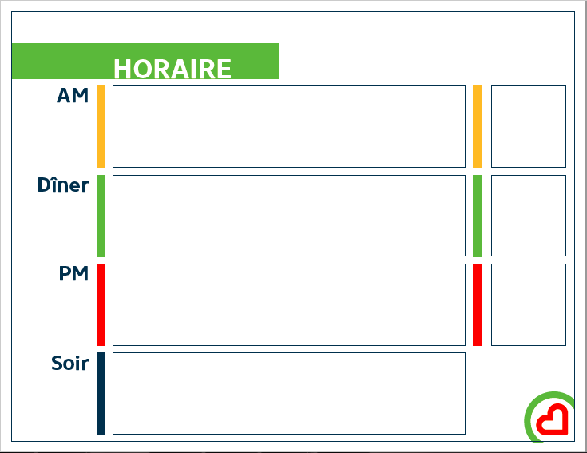

**HORAIRE**

**Jour de la semaine**

**AM**

**Dîner**

**PM**

**Soir**



|  |  |  |  |  |  |  |  |  |
| --- | --- | --- | --- | --- | --- | --- | --- | --- |
| 7h00 | 7h30 | 8h00 | 8h30 | 9h00 | 9h30 | 10h00 | 11h00 | 11h30 |
|  |  |  |  |  |  |  |  |  |

|  |  |  |  |
| --- | --- | --- | --- |
| 12h00 | 12h30 | 13h00 | 13h30 |
|  |  |  |  |

|  |  |  |  |  |  |  |
| --- | --- | --- | --- | --- | --- | --- |
| 14h00 | 14h30 | 15h00 | 15h30 | 16h00 | 16h30 | 17h00 |
|  |  |  |  |  |  |  |

|  |  |  |  |  |  |  |  |
| --- | --- | --- | --- | --- | --- | --- | --- |
| 17h30 | 18h00 | 18h30 | 19h00 | 19h30 | 20h00 | 20h30 | 21h00 |
|  |  |  |  |  |  |  |  |

**ICÔNES**





